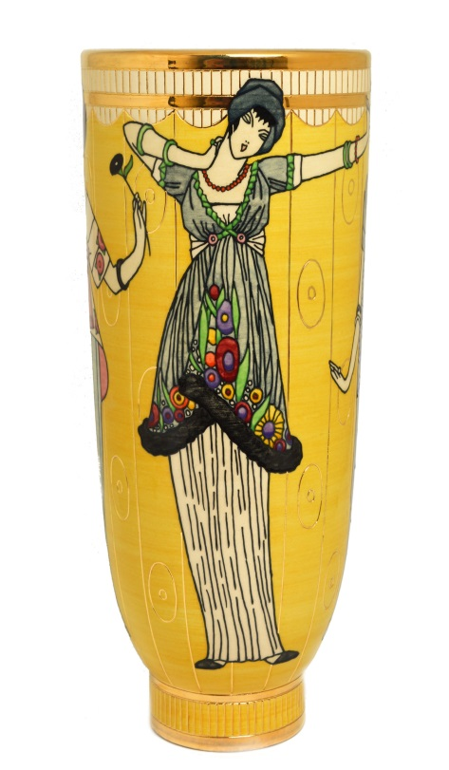

DENNIS CHINAWORKS

Andy and Mary Whettem are holding a Xmas Open Day on
Sunday, December 13th from 11.00am – 4.00pm
at
The Barn, Corner Cottage,
Bignor,
Nr. Pulborough, West Sussex RH20 1PQ

We will have the full range of Dennis Chinaworks available including
all the new designs plus many discontinued pieces.
Sally, Richard and Buchan will be here to chat to and sign pieces and there
will be mulled wine and refreshments.
We hope you can join us.

Bignor is off the A29 between Pulborough and Arundel.
We are immediately to the left of Bignor Church. R.S.V.P. Tel: 01798 869252
Please Park as directed. email: mary@whettem.co.uk

Please let us know if you no longer wish to be
on our mailing list.

